Adler Community Health Services’
Division of Teen Wellness & Opportunity

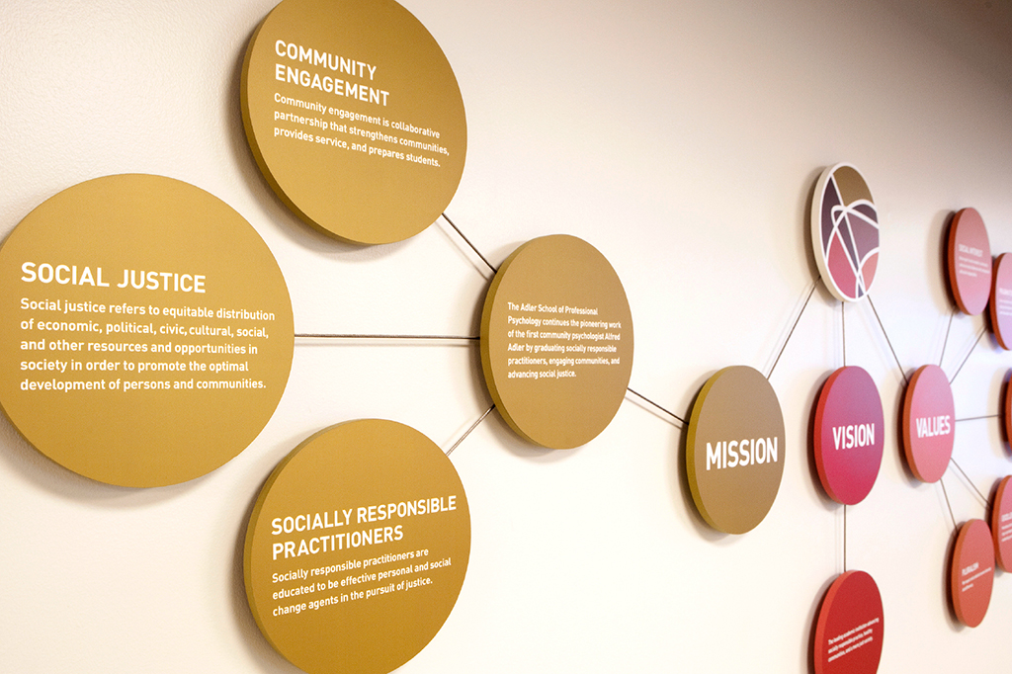
Internship Program
2022-2023 Brochure

WELCOME

I am pleased to offer you this information about the APA-accredited Adler Internship Program, which is part of the Adler Community Health Services' (ACHS’) Division of Teen Wellness and Opportunity. Services will be provided onsite at one of our community-based partnership sites in the Chicagoland area that serve underserved adolescents. Some opportunities for telehealth services will be available as well.

The training team includes the Director of Training (DoT), two licensed clinical psychologists, and community-based mental health services site administrators. The DoT and licensed clinical psychologists are the primary supervisors conducting clinical supervision and training for program interns. Additionally, multidisciplinary staff are also available to provide additional supplementary consultation, role modeling, and support for the interns (known as adjunct staff). These adjunct staff clinicians are not directly responsible for the program requirements and do not have primary responsibility for intern training, supervision and program development. Interns work and interact regularly with these adjunct staff who serve as a professional and collegial resource. Through the onsite experiences, interns develop proficiency in the nine profession-wide competencies outlined in Section II.B.1.b. of the Standards of Accreditation. The primary objective of the program is to prepare interns to become entry-level health service psychologists.

The program has been designed to provide you with an array of learning experiences to broaden your knowledge, enhance your skills, and facilitate the consolidation and integration of your professional identity within the context of preparing you to become a socially responsible practitioner. You will provide individual, group and family therapy. You will conduct intakes and complete full batteries of psychological assessments. Finally, you will participate in individual and group supervision, weekly seminars, monthly training days, case presentations, and other professional development experiences.

If you have any questions about our internship program after reviewing the information in this brochure, please do not hesitate to contact me at cmurphy@adler.edu and I will be happy to provide any further information you need.

Cara Murphy, Psy.D.
Director of Training

Overarching Program Aim
The purpose of the program is training of doctoral interns for Health Service Psychologist in professional psychology. The program identifies two specific goals in this preparation.

The primary goal of the program is to prepare interns for entry level clinical psychology practice who are grounded in the foundational scientific knowledge of the profession and who have applied functional skills for competent practice. A second and related goal is to prepare interns for Health Service Psychologist that integrates socially responsible practice skills and an appreciation of social justice issues.

Consistent with the mission and philosophy of the Adler University and ACHS, the program gives interns an opportunity to explore the application of psychological knowledge and skills to help individuals, groups and families as well as the need for addressing systemic problems, developing increased awareness of social issues, working with underserved populations and fostering social change. To accomplish this, the internship program provides interns with sequential, cumulative, and structured learning experiences. Through the program training curriculum and activities, interns develop proficiency in knowledge and skills across the profession wide competency areas of clinical psychology as well as the values and attitudes of the profession. The program follows a practitioner-scholar model outlined by the National Council of Schools and Programs of Professional Psychology (NCSPP) with one additional area of training identified as socially responsible practice.

Supervision Requirements

Interns are required to participate in a minimum of one hour of individual supervision with each of their training supervisors (licensed clinical psychologists) for a total of two hours of individual supervision weekly. In addition, interns are required to participate in two hours of group supervision weekly with the designated training supervisor(s).
Additional Training Information
Supervision of Externs
Interns are taught to develop supervisory/management skills by managing and training externs. Each intern is assigned one extern and is responsible for their extern team’s supervision. In this context, the intern’s role is threefold: administrative supervisor, peer clinical supervisor, and mentor.

Stipend & Benefits
The annual stipend is $31,500. Health insurance benefits are provided to interns. Interns are provided with 80 paid vacation hours and 80 paid sick hours. Other benefits include holidays and a paid offsite training experience.

Requirements for Completion
Interns must complete 2,080 hours within the training year (September 1, 2022 –August 31, 2023). Interns must demonstrate that they have attained the competencies taught in the internship, as measured by ratings of “Satisfactory” or higher on all competencies on the final written evaluation, given at the end of the training year.
Accreditation Status
The Adler Internship Program – ACHS Division of Teen Wellness & Opportunity is accredited by the American Psychological Association. The Commission on Accreditation of the APA can be contacted at:

Commission on Accreditation
Office of Program Consultation and Accreditation
American Psychological Association
750 First St. NE
Washington, DC 20002-4242
(202) 336-5979
Email: apaaccred@apa.org

APPIC Membership Status
The Adler Internship Program – ACHS Division of Teen Wellness & Opportunity is currently a member of the Association of Psychology and Postdoctoral and Internship Centers (APPIC) and participates in the APPIC Match Service. ACHS abides by the APPIC policy that no person at this training facility will solicit, accept, or use any ranking-related information from any intern application. Find the APPI OnLine here.

Intern Selection Criteria and Procedures
The program participates in the APPIC selection process and utilizes the APPI online application. Our program complies with all APPIC internship match procedures and policies. Information about the program, requirements and application procedures are listed in the APPIC directory. Applicants for the internship training program are required to meet the following conditions to be given full consideration:

Minimum requirements:
1. Completion of a 750-hour diagnostic practicum; 750-hour intervention practicum and a minimum total of 400 APPI intervention hours
2. Minimum 3 years of graduate training in a psychology doctoral program
3. Comprehensive Exams and doctoral dissertation proposal passed by application deadline
4. Enrolled and in good standing in an APA accredited doctoral psychology graduate program.
5. Endorsement by their training department director regarding their readiness for internship.

Preferred criteria:
1. 400 hours supervised psychotherapy experience (individual, group, family) in graduate level practicum including evidence based treatment approaches
2. Psychotherapy / Assessment experience with adolescent populations
3. Psychotherapy experience in working with clients who have been exposed to trauma
4. Experience providing process oriented group psychotherapy
5. Coursework in supervision

Additional relevant experience:
1. Crisis intervention
2. Outreach and consultation
3. Providing clinical supervision and/or clinical supervision coursework

Applicants must submit their information through the online application process and APPI information must include, as a part of the application, the following:

- Cover letter explaining (1) why you believe you would be a good fit with the Teen Wellness and Opportunity Adler Internship Program, (2) what your goals for internship are, (3) and how our program would help meet these training goals.
- Three letters of reference: at least 2 of these letters should be from clinical supervisors (and at least one of these should be from your most recent clinical supervisor)
- Verification of internship readiness from your graduate program training director
- Current curriculum vitae
- Official graduate transcript

The internship selection committee (which typically consists of the Training Director, supervisors, post-doctoral resident and additional staff members as needed), review and assess the application materials ranking the applications. Based on the criteria established above, a subgroup of top applicants is selected and offered an interview with members of the committee. *Due to the global pandemic, and to support a safe and equitable process, all interviews for the 2022-2023 training year will be done virtually. Following the completion of all interviews, the internship selection committee will meet to determine how each candidate will be ranked, based on preferred criteria and relevant experience as well as including compatibility of applicant philosophy presented in APPI essays with the values, approaches, and professional functions of the training program. Those candidates whose experiences are most compatible with the training program’s mission will be ranked for the APPIC match. Throughout the selection process, APPIC guidelines are strictly followed.

Interns matched with the program are sent a Letter of Appointment within 72 hours. A copy of this acceptance letter is also sent to the intern applicant’s home graduate program.

